ASSIGNMENT 4

|  |
| --- |
| TEAM ID PNT2022TMID07573 |
| PROJECT NAME NUTRITION ASSISTANT APPLICATION |
| TEAM LEADER Shreetha.M |
| TEAM MEMBERS Shwathi.R.M  Soundarya.D  Sangeetha.S |

1. Pull an image from docker hub and run it in docker playground.

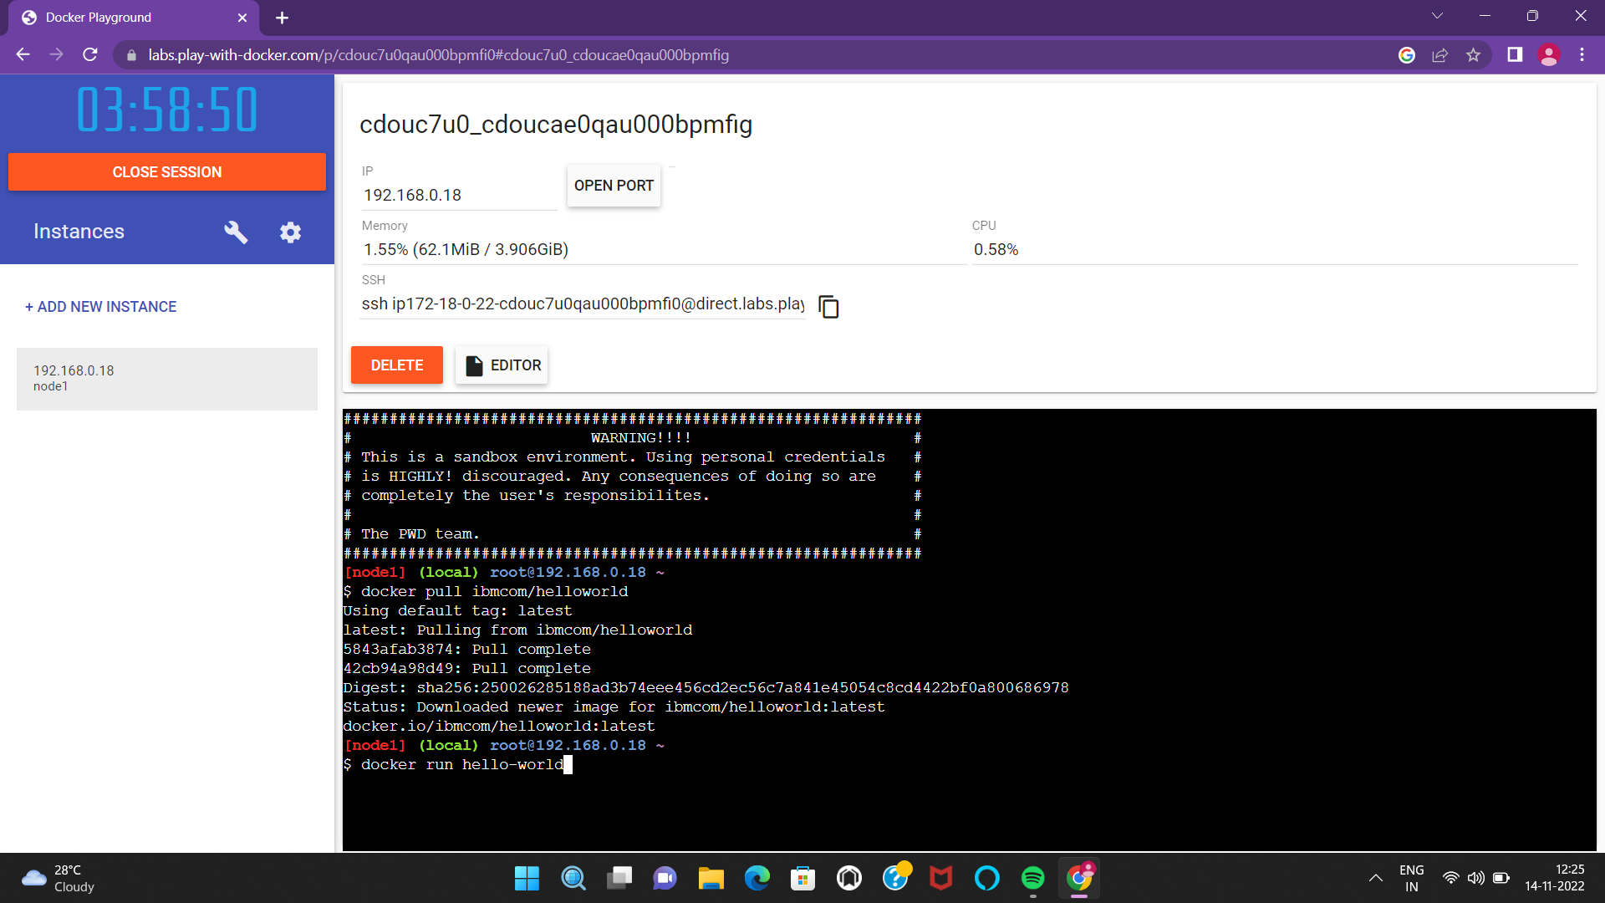

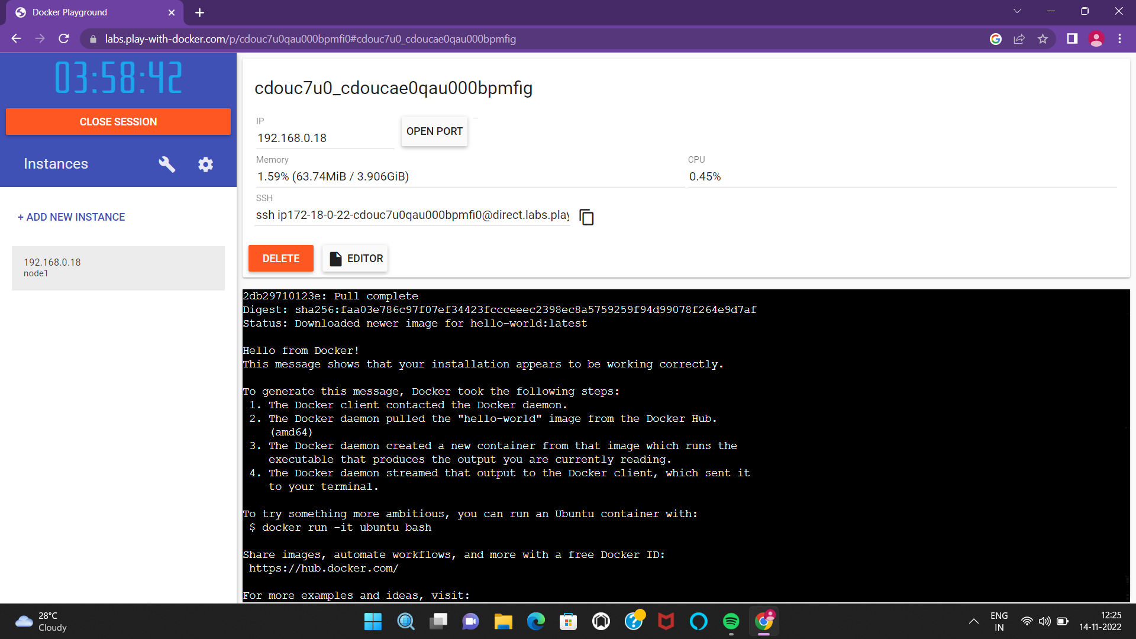

2. Create a docker file for the jobportal application and deploy it in Dockerdesktop application.

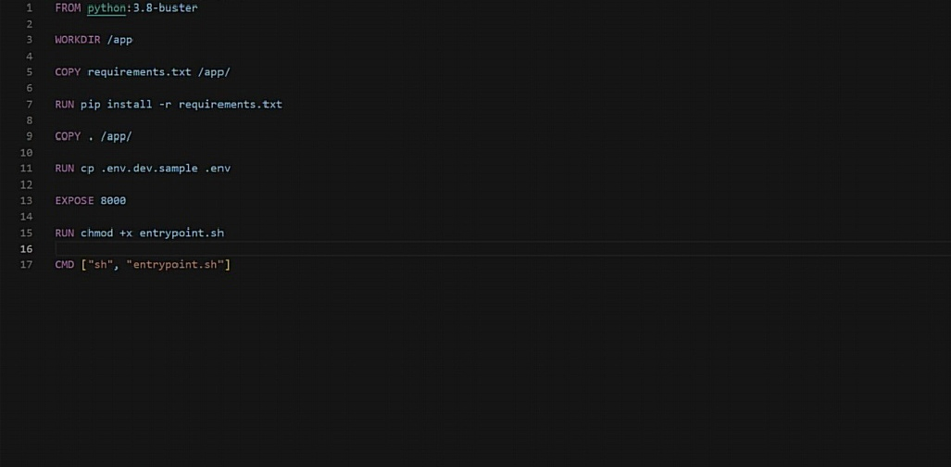

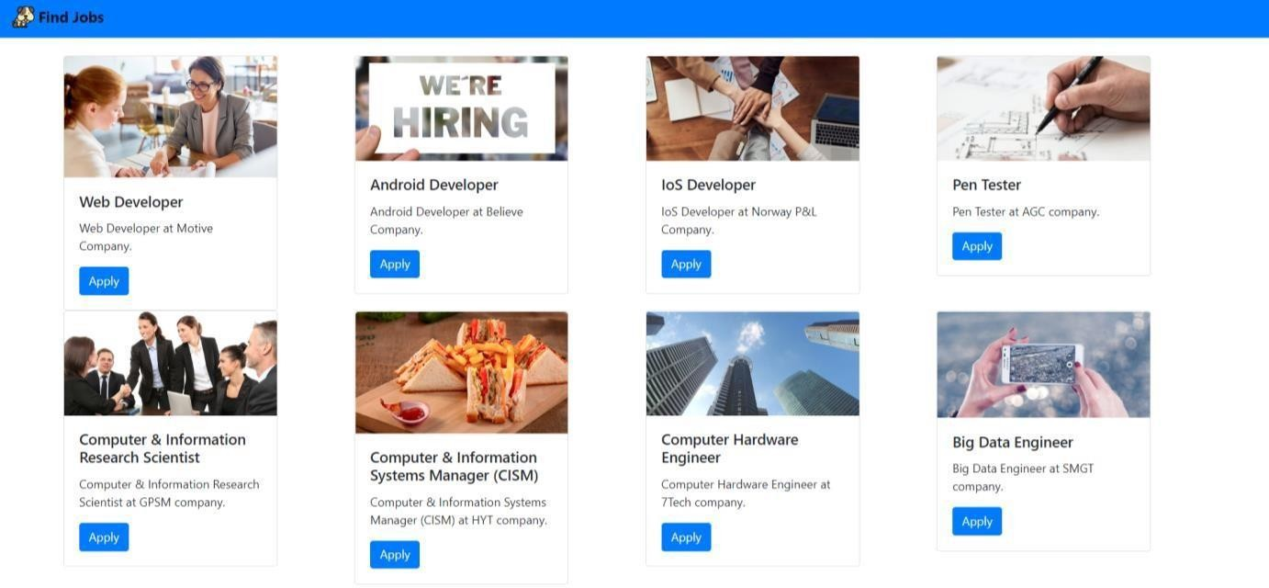

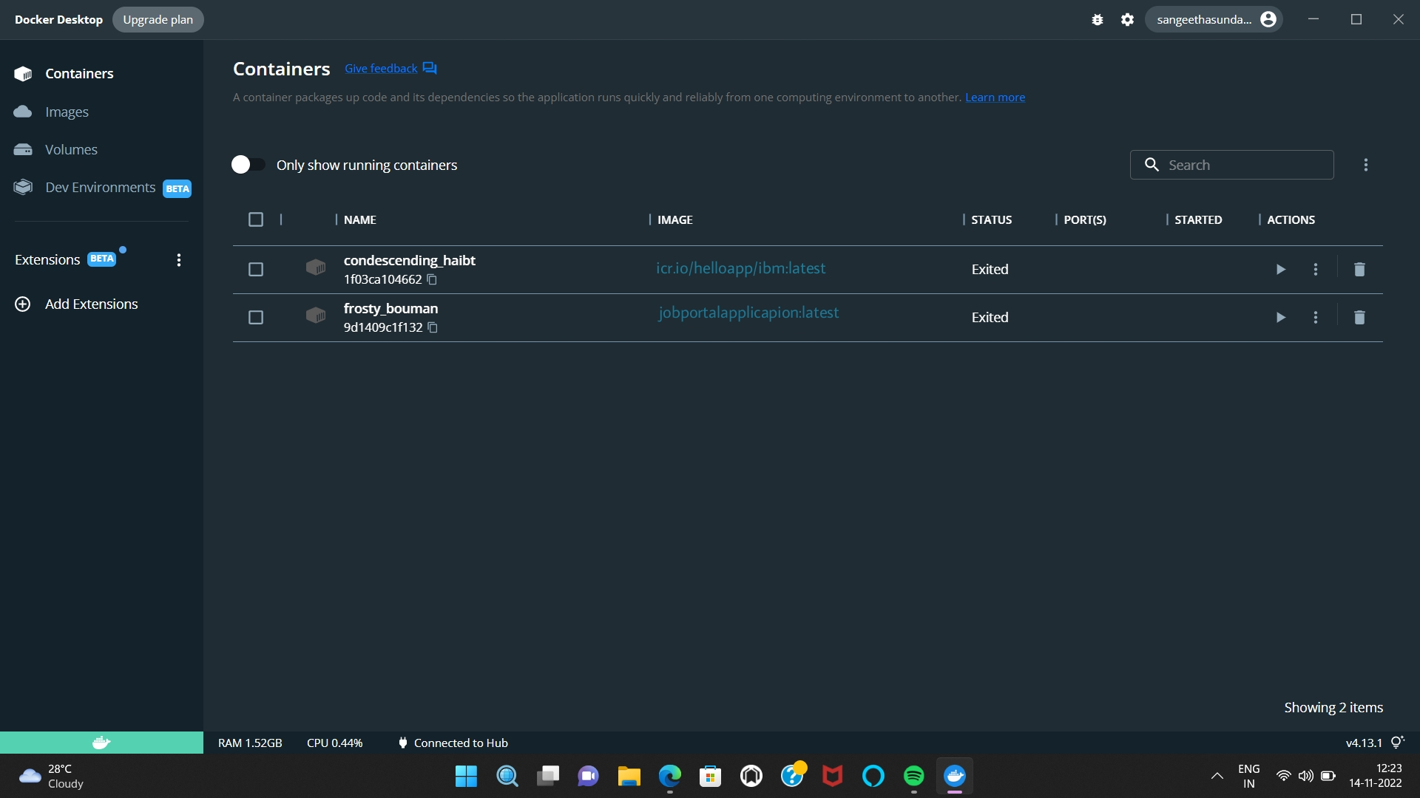

OUTPUT

3. Create a IBM container registry and deploy hello world app or job portapp.

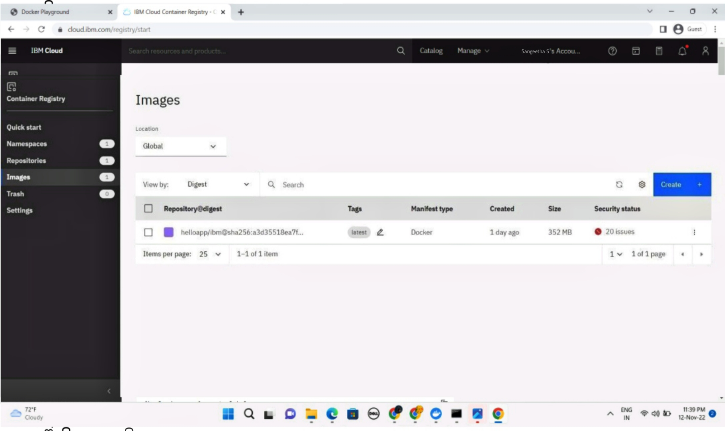

4. Create a Kubernetes cluster in IBM cloud and deploy helloworld image or jobportal image and also expose the same app to run in nodeport.

